Name of Big Bear Banter Pack | Dates | Names of Absent Pupils | Comments
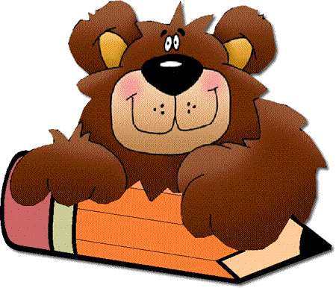
Big Bear Banter Group Names _______________________________________
________________________________________________________________
Session __________ Group Leader __________________
Name of Big Bear Banter Pack | Dates | Names of Absent Pupils | Comments
Colours

Shapes

Numbers

Classroom Objects

Parts of the Body

Name of Big Bear Banter Pack | Dates | Names of Absent Pupils | Comments
Family

Feelings

Clothes

Weather

Food

Name of Big Bear Banter Pack | Dates | Names of Absent Pupils | Comments
Fruit

Vegetables

Transport

Verbs

Farm Animals

Name of Big Bear Banter Pack | Dates | Names of Absent Pupils | Comments
Pets

Animals

Minibeasts

Prepositions

Days of the Week

Name of Big Bear Banter Pack | Dates | Names of Absent Pupils | Comments
Hobbies

Months

Places

Sport

Time

Name of Big Bear Banter Pack | Dates | Names of Absent Pupils | Comments
Easter

Hallowe’en

Winter

Four Seasons

Chinese New Year

Name of Big Bear Banter Pack | Dates | Names of Absent Pupils | Comments
Diversity
The Gruffalo

Name of Big Bear Banter Pack | Dates | Names of Absent Pupils | Comments

