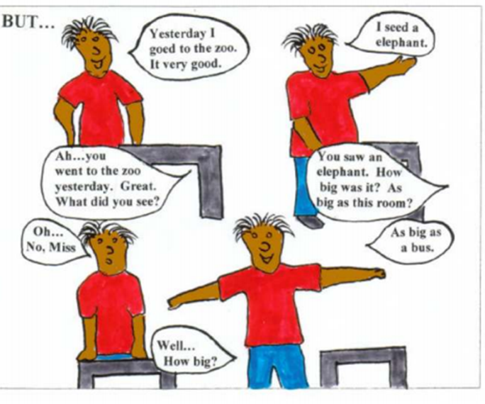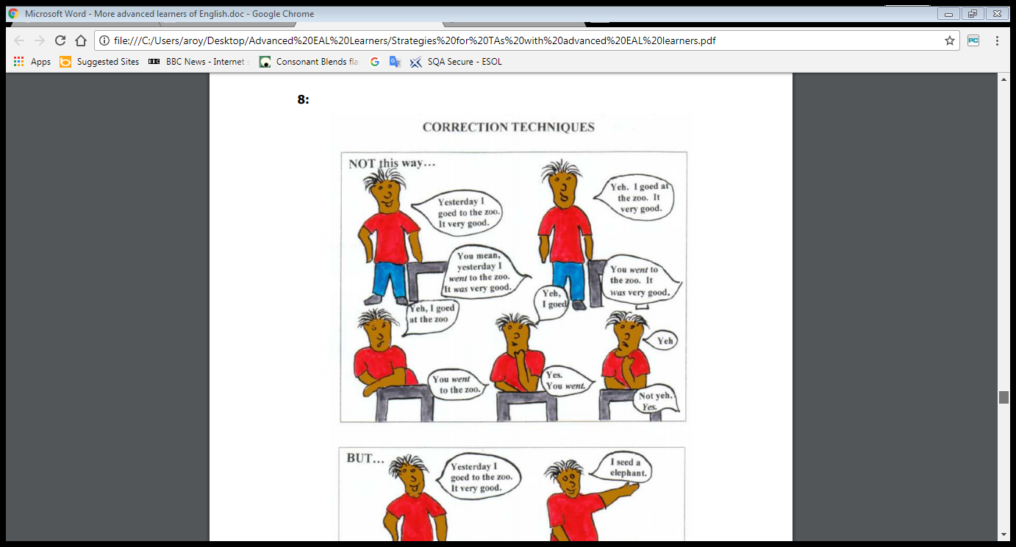

**Try to avoid correcting and pointing out errors**

**Instead model and extend e.g. by asking questions**