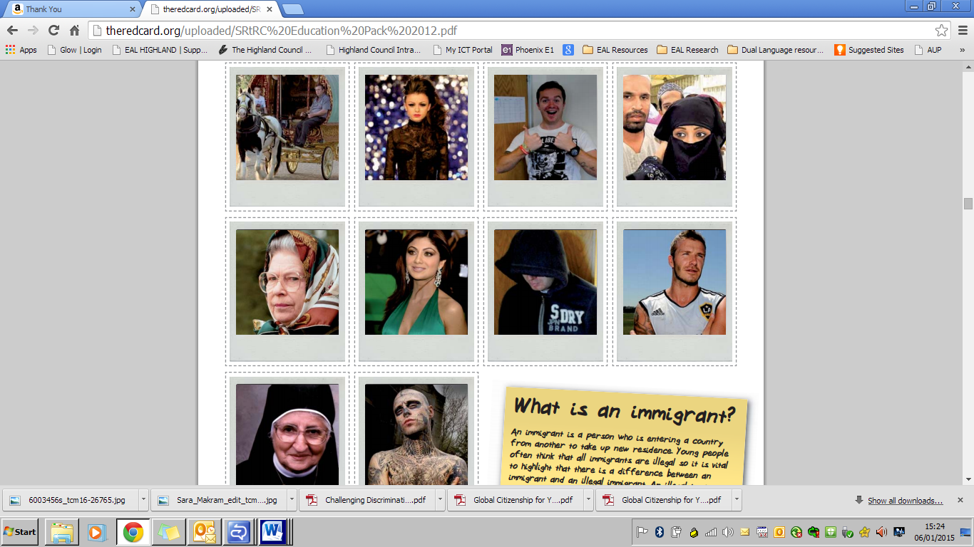

Look at these pictures and ask the children to describe the people in them. Ask questions to draw comparisons eg. who has their head covered?

Images from *Show Racism the Red Card*

