Hot Seating
by David Farmer | Dec 22, 2014 | Drama Strategies

What is Hot Seating?
A character is questioned by the group about his or her background, behaviour and motivation. The method may be used for developing a role in the drama lesson or rehearsals, or analysing a play post-performance. Even done without preparation, it is an excellent way of fleshing out a character. Characters may be hot-seated individually, in pairs or small groups. The technique is additionally useful for developing questioning skills with the rest of the group.
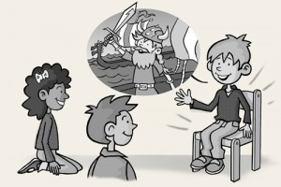

How do you do hot seating?
The traditional approach is for the pupil playing the character to sit on a chair in front of the group (arranged in a semi-circle), although characters may be hot-seated in pairs or groups. It is helpful if the teacher takes on the role of facilitator to guide the questioning in constructive directions.To help students begin you can try hot-seating children in pairs (e.g. a pair of street urchins) or in groups (e.g. environmental protesters, refugees).
If the background of the character is familiar to the pupils, then it may not be necessary for those playing the characters to do much preparation. Although some roles obviously require research you may be surprised at how much detail students can add from their own imaginations. It is important that the rest of the group are primed to ask pertinent questions. Don’t get bogged down in facts during hot seating, but concentrate on personal feelings and observations instead.

Examples
Characters to hot seat include characters from texts or famous people such as Florence Nightingale, President Kennedy or Tutankhamen as well as ordinary people like a chimney sweep, a Roman soldier or a Saxon farmer. Students can be asked to research historical characters with opposing points of view and then be hot-seated by the class as part of a debate.

