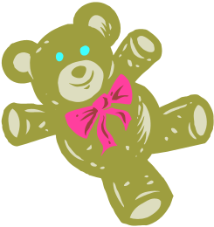

TEDDY TALK
EXTENSION ACTIVITIES FOR BILINGUAL PUPILS
E A L H i g h l a n d

E A L H i g h l a n d
E A L H i g h l a n d
E A L H i g h l a n d
E A L H i g h l a n d
E A L H i g h l a n d
E A L H i g h l a n d
E A L H i g h l a n d

My House: Three Little Pigs

Activities | Materials | Language
Rules for good looking/listening/sitting  Sit in semi-circle | - Good looking card  - Good listening card  - Good sitting card  - Where and Who Makaton signs, if known | - Good looking  - Good listening  - Good sitting
Hello Song  Pass the teddy to the child while saying the name  Sing hello song  Ask “who” the child is going to choose next | - Teddy | - Words of song  - Names of children and teachers  - “How are you today?”  - “I’m good” “I’m fine thanks”
Introduce Vocabulary  Using doll’s house or picture of cross-section of house, introduce vocabulary | - Doll’s house or  - Usbourne First Hundred Words in English or  - Flashcard below | - House / Kitchen  - Living room  - Bedroom / Bathroom  - Kitchen
Reinforce Vocabulary  Take flashcards from bag, ask where it goes  Use either/or or open questions | - Flashcards of cooker, settee, bed, bath below | - Does it go in the kitchen or the bedroom?  - Where does this go?  - In the bedroom. etc
Game  Either Corners – put flashcards in corners of room, tell children to go to the kitchen etc.  If confident, children can give instructions  Or – Jump – children stand one behind another, teacher holds a picture in each hand, says one of rooms, children jump in that direction | - Flashcards of house and rooms below | - House  - Kitchen  - Living room  - Bedroom  - Bathroom
Story  Tell story – children may be able to join in repetitive parts | - The Three Little Pigs - traditional
Goodbye Song  Now it’s time to say goodbye (tune of Mulberry Bush)  Say goodbye to each object – child pops it in the bag when they hear their object | - Bag | - Goodbye object



