Plan of the Citadel of Mohenjo-Daro

The stupa was a large square building in the north-east of the city.
In the south-east corner of the city there were
fortifications.
The college was next to the stupa and was rectangular in shape.
The granary was just to the north of the stairs.
The public bath house was between the granary and the college and was rectangular but not as long as the college.
The assembly hall was to the south of the college and to the north-east of the fortifications.
The tower was L- shaped and was in the west of the
citadel.

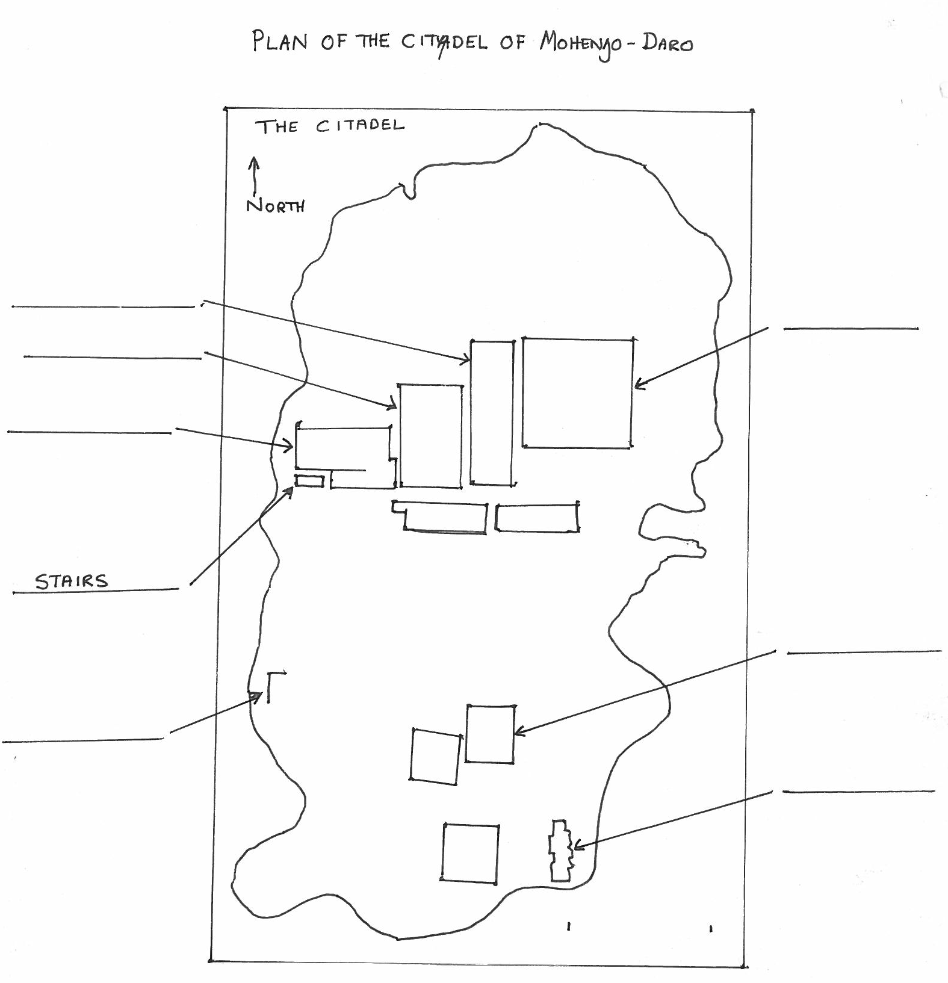
the college
the granary
fortifications
the bath house
the tower
the stupa
Plan of the Citadel of Mohenjo-Daro
the assembly hall

