The Best 37 English Idioms for ESL Students to Learn

1. a storm is brewing
Meaning: There will be trouble or emotional upset in the near future.
Example: “She decided to go ahead with their wedding, even though all they’ve been doing lately is arguing. I can sense a storm is brewing.”

2. calm before the storm
Meaning: An unusually quiet period before a period of upheaval (problems, chaos).
Example: “The strange quietness in town made her feel peaceful. Little did she know, it was just the calm before the storm.”

3. weather a storm
Meaning: To survive a dangerous event or effectively deal with a difficult situation.
Example: “Last year, they had some financial difficulties when her husband was fired. Together, they weathered the storm and figured out how to keep going.”

4. when it rains, it pours
Meaning: Bad things occur in large numbers; many big things happen all at once.
Example: “First he was made redundant, then his wife got into a car accident. When it rains, it pours.”

5. chasing rainbows
Meaning: Following dreams, trying to do something that can’t be achieved.
Example: “His paintings have neither style nor imagination, but he insists on being a professional painter. He’s always chasing rainbows.”

6. rain or shine
Meaning: No matter what happens.
Example: “I’ll see you at the airport, rain or shine.”

7. under the sun
Meaning: In existence.
Example: “Gili Trawangan must be one of the most beautiful islands under the sun.”

8. once in a blue moon
Meaning: Very rarely.
Example: “He used to call his grandma once in a blue moon. Now that she has passed away, he regrets not making more of an effort to keep in touch.”

9. every cloud has a silver lining
Meaning: There’s a good aspect to every bad situation.
Example: “Don’t worry about losing your job. It will be okay. Every cloud has a silver lining!”

10. a rising tide lifts all boats
Meaning: When an economy is performing well, all of the people involved will benefit from it.
Example: “When the economy showed the first signs of recovering, everyone started investing and spending more. A rising tide lifts all boats.”

11. get into deep water
Meaning: To be in trouble.
Example: “He got into deep water when he borrowed a lot of money from a loan shark.”

12. pour oil on troubled waters
Meaning: To try to make people feel better and become friendly again after an argument.
Example: “She hated seeing her two best friends arguing, so she got them together and poured oil on troubled waters.”
This expression comes from the calming effect that oil has on waves as it spreads over the surface of the sea. With the ecological disasters following big oil spillage in recent years, some people might now think of this phrase rather differently compared to its original meaning—but it’s still interesting to know about.

13. make waves
Meaning: To cause trouble, to change things in a dramatic way.
Example: “She likes to make waves with her creative marketing campaigns. They get a lot of attention from customers.”

14. go with the flow
Meaning: To relax and go along with whatever is happening.
Example: “Quite often in life, good things happen when you don’t make plans. Just go with the flow and see what happens!”

15. lost at sea
Meaning: To be confused about something, to feel unsure about what to do.
Example: “I am lost at sea with this new system at work. I just can’t understand it.”

16. sail close to the wind
Meaning: To act just within the limits of what’s legal or socially acceptable, to push boundaries.
Example: “They fired their accountant because he sailed too close to the wind.”

17. make a mountain out of a molehill
Meaning: To exaggerate the severity of a situation.
Example: “She shouted at him angrily for being five minutes late, but it really didn’t matter that much. She really made a mountain out of a molehill.”

18. gain ground
Meaning: To become popular, to make progress, to advance.
Example: “As Airbnb gains ground in many cities all over the world, many locals complain that they can no longer find a place to live. Landlords would rather rent their places out to tourists and earn more money.”

19. walking on air
Meaning: Very excited or happy.
“Over the moon,” “on cloud nine,” “in seventh heaven” and “in good spirits” are a few more advanced English phrases you can use to talk about happiness.
Example: “She’s been walking on air since she found out that she’s pregnant.”

20. many moons ago
Meaning: A long time ago.
Example: “Many moons ago, we used to be two very close friends. Now we’ve gone separate ways and lost contact.”

21. castle in the sky
Meaning: A daydream, a hope, especially for one’s life, that’s unlikely to come true.
Example: “World traveling used to be a castle in the sky for most people a few decades ago, but with cheap flight tickets and the global use of English, many youngsters are living that dream.”

22. down to earth
Meaning: To be practical and sensible.
Example: “It’s a stereotype, but Dutch people are known for being down to earth.”

23. salt of the earth
Meaning: Being honest and good.
Example: “My father is the salt of the earth. He works hard and always helps people who are in need.”

24. the tip of the iceberg
Meaning: Just a small part of something much bigger.
Example: “Exceptionally long drought periods are just the tip of the iceberg when it comes to the global impact of climate change.”

25. break the ice
Meaning: To attempt to become friends with someone.
Example: “He made a weather joke to break the ice.”

26. sell ice to Eskimos
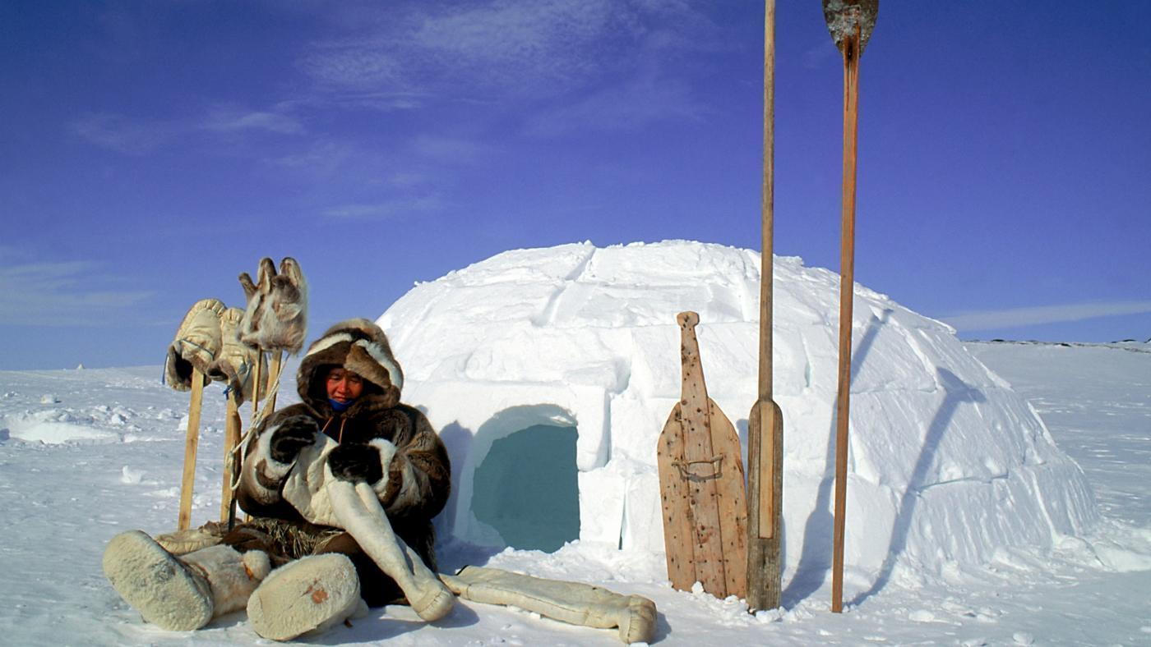
Meaning: To be able to sell anything to anyone; to persuade people to go against their best interests or to accept something unnecessary or preposterous.
Eskimos are indigenous people who live in very cold, snowy regions—they don’t need any ice! If you can sell ice to them, you can sell anything to anyone.
Example: “He’s a gifted salesman, he could sell ice to Eskimos.”

27. bury your head in the sand
Meaning: To (try to) avoid a particular situation by pretending that it doesn’t exist.
Example: “Stop burying your head in the sand. You haven’t been happy with him for years, why are you staying together?”

28. let the dust settle
Meaning: To allow a situation to become calm or normal again after something exciting or unusual has happened.
Example: “You just had big news yesterday, let the dust settle and don’t make any decisions yet.”

29. clear as mud
Meaning: Not clear at all, not easy to understand.
Example: “He’s a great scientist, but I find his explanation of bacteria and microbes as clear as mud.”

30. as cold as stone
Meaning: Being very cold and unemotional.
Example: “In the Victorian times, many women were told to suppress their feelings and, thus, appeared as cold as stone.”

31. between a rock and a hard place
Meaning: In difficulty, faced with a choice between two unsatisfactory options.
Other phrases with a similar meaning are “the lesser of two evils,” “between the devil and the deep blue sea,” “between Scylla and Charybdis,” “Hobson’s choice” and “Catch-22.”
Example: “I can understand why she couldn’t make up her mind about what to do, she’s really between a rock and a hard place.”

32. nip something in the bud
Meaning: To stop a bad situation from becoming worse by taking action at an early stage of its development.
Example: “When the kid shows the first signs of misbehaving, you should nip that bad behavior in the bud.”

33. barking up the wrong tree
Meaning: Doing something that won’t give you the results you want.
Example: “If you think she’s going to lend you money, you’re barking up the wrong tree. She never lends anyone anything.”

34. out of the woods
Meaning: The situation is still difficult but it has improved or gotten easier, the hardest part of something is over.
Example: “The surgery went very well and he just needs to recover now, so he’s officially out of the woods.”

35. can’t see the forest for the trees
Meaning: To be unable to see the whole situation clearly because you’re looking too closely at small details.
Example: “He’s worried because the flowers haven’t all arrived, but everyone says the wedding has been perfect and beautiful. He just can’t see the forest for the trees.”

36. to hold out an olive branch
Meaning: To offer to make peace (with a rival or enemy).
Example: “After years of rivalry with her cousin, she decided to hold out an olive branch and go have fun together.”

37. beat around the bush
Meaning: To spend a long time getting to the main point of what you’re saying, especially because it’s embarrassing.
Example: “I don’t have much time, so stop beating around the bush and tell me what actually happened.”
I hope these 37 idioms will inspire you to keep learning and using English more poetically and more naturally.

