Colours  red blue yellow green  black brown orange pink  white purple  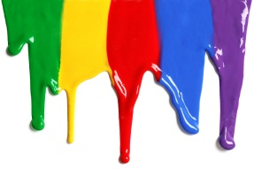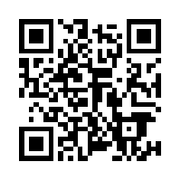  How good are you at this? | Shapes  square triangle diamond  circle rectangle oval  star heart  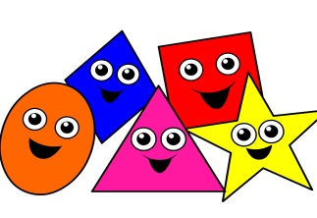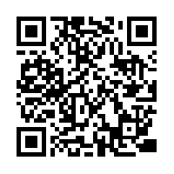  How good are you at this?
Numbers  zero one two three four five six seven eight nine ten eleven twelve thirteen fourteen fifteen sixteen seventeen eighteen nineteen twenty  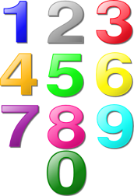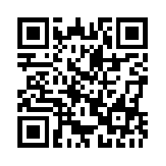  How good are you at this? | Classroom Objects  classroom pencil pen crayons paper book ruler scissors notebook eraser pencil sharpener desk blackboard computer chair  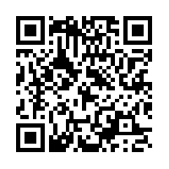  How good are you at this?

Parts of the Body  head hair face nose ear eye mouth teeth neck hand finger arm elbow knee shoulder back foot toe leg  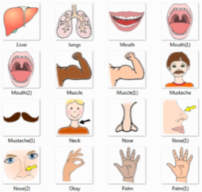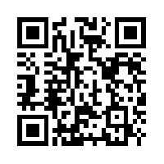  How good are you at this? | Family  family mum dad parents sister brother brother and sister sisters brothers grandmother grandfather grandparents mother and son father and son father and daughter mother and daughter  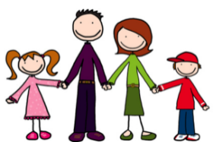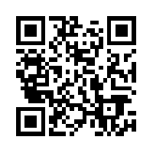  How good are you at this?
Feelings  happy angry sad hot tired hungry sick thirsty cold shy tired in love  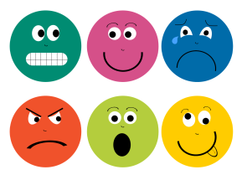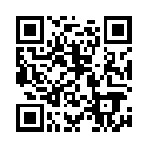  How good are you at this? | Food  salad bread spaghetti soup fish chicken chips cheese burger hotdog pizza sandwich cereal cheese bacon and eggs rice steak  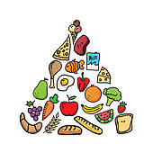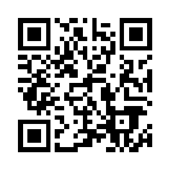  How good are you at this?

Weather  sunny partly cloudy cloudy raining snowing stormy foggy beautiful/perfect cold hot windy clear  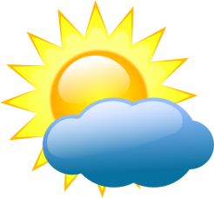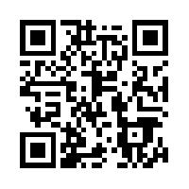  How good are you at this? | Clothes  t-shirt hat shorts skirt socks shoes tie shirt dress pants pyjamas swimsuit gloves coat underwear  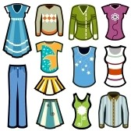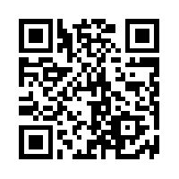  How good are you at this?
Fruit  pineapple grapes blueberries strawberry kiwi bananas pear orange lemon apple watermelon peach cherries grapefruit plum  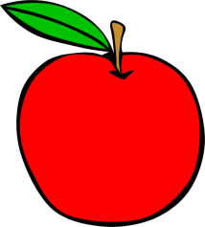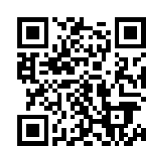  How good are you at this? | Vegetables  onions green peppers tomatoes mushrooms lettuce broccoli potatoes carrots pumpkin beans peas radishes cabbage corn eggplant cucumber  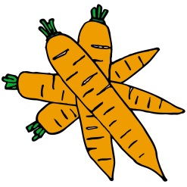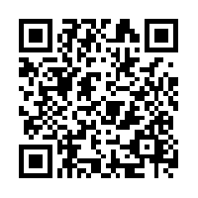  How good are you at this?

Transport  fire engine police car ambulance taxi truck motorcycle bus train bike airplane helicopter tank boat submarine rocket UFO jeep sports car van  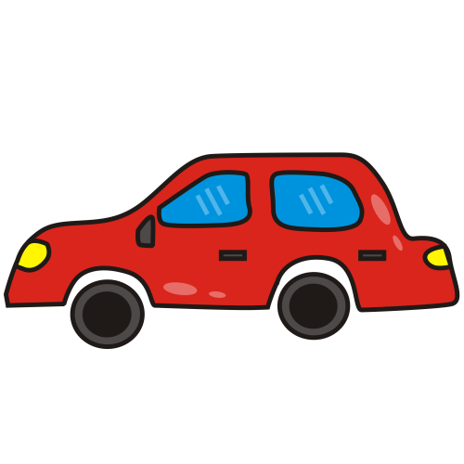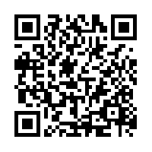  How good are you at this? | Verbs  walk run read play sleep write talk listen jump drink eat open close  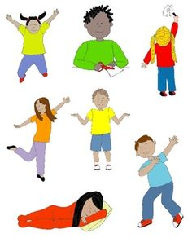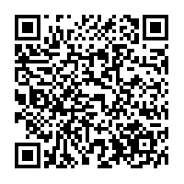  How good are you at this?
Farm Animals  cow horse sheep pig hen duck dog goat cockerel sheep dog  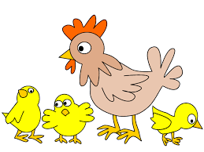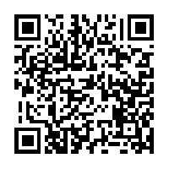  How good are you at this? | Pets  cat dog rabbit gerbil rat mouse hamster guinea pig budgie parrot goldfish spider snake crab  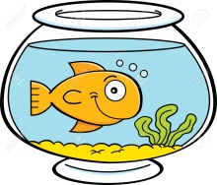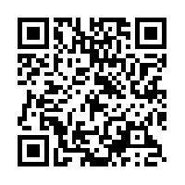  How good are you at this?

Wild Animals  lion zebra giraffe hippo elephant rhino crocodile snake tiger kangaroo  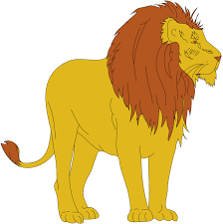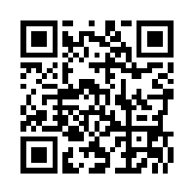  How good are you at this? | Minibeasts  dragonfly worm slug wasp caterpillar woodlouse butterfly bee millipede ladybird snail fly  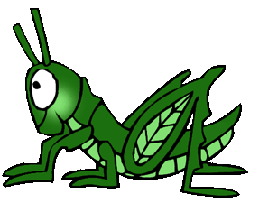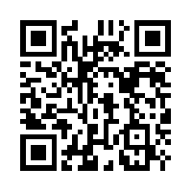  How good are you at this?
Prepositions  behind in front of in by over between under on  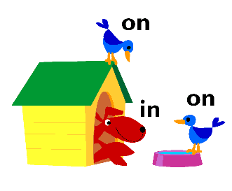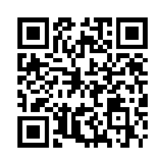  How good are you at this? | Days of the week  Sunday Monday Tuesday Wednesday Thursday Friday Saturday week today yesterday tomorrow morning afternoon evening night day  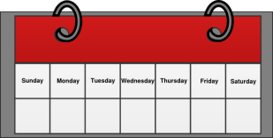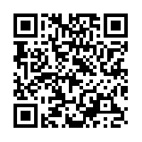  How good are you at this?

Winter  snowballs snowflake icicles snowman hat gloves scarf coat boots skis sledge skates  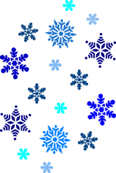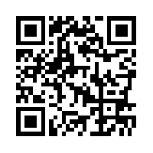  How good are you at this? | Months  January February March April May June July August September October November December  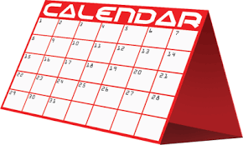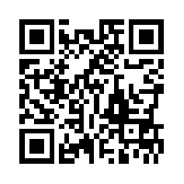  How good are you at this?
Senses  smell see hear taste touch spicy sweet juicy salty rough cold smooth soft loud quiet bright dark smokey pungent  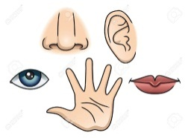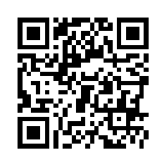  How good are you at this? | Sport  football baseball American football golf basketball ice hockey rugby field hockey volleyball badminton table tennis/ ping pong tennis  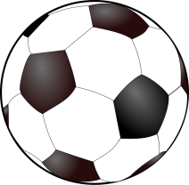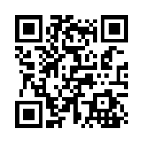  How good are you at this?

Chinese New Year

China Chinese Happy New Year paper dragons lanterns balloons money wallet noodles chopsticks

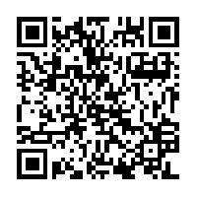

How good are you at this?

