School subjects  English Science Maths PE/Gym Music Social Studies Art ICT HE Spanish French (lunch break)  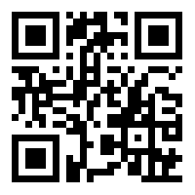  How good are you at this? | Places in a school  classroom music room art room library gym hall science room cafeteria lockers/hall head teacher's office sports field pool computer room theatre toilets bus stop stair well staffroom/office car park  Turn left, turn right, go straight on, go up the stairs, go down the stairs/ Where is the …?  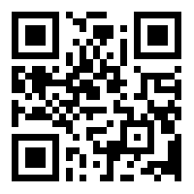  How good are you at this?
Hobbies  dance painting cooking playing an instrument singing reading playing computer games listening to music cycling running swimming skateboarding watching TV roller-skating playing cards playing football  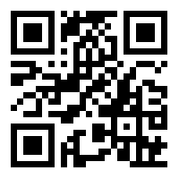  How good are you at this? | Time  1:00, 2:00, 3:00, 4:00, 5:00, 6:00, 7:00, 8:00, 9:00, 10:00, 11:00, 12:00, 2:15, 3:30, 7:45, 4:05, 4:10, 5:55  quarter to, quarter past, half past, five to, What time is it?  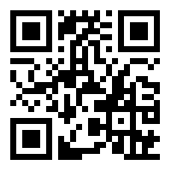  How good are you at this?
Numbers 1 – 100+  One hundred and fifty two thousand three hundred and sixty-five etc.  1st, 2nd, 3rd etc.  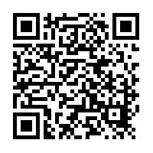  How good are you at this? | Money  5 pence 10 pence 20 pence 50 pence 1 pound 5 pounds  How much is it/that? That’s £2.63, please.  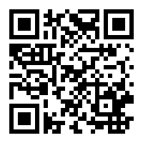  How good are you at this?
Fruit  pineapple grapes blueberries strawberry kiwi bananas pear orange lemon apple watermelon peach cherries grapefruit plum  Would you like a/some…? Yes, please/ No, thanks.  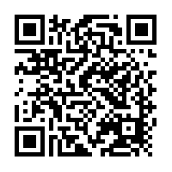  How good are you at this? | Food  Salad bread spaghetti soup fish chicken corndog French fries cheese burger hotdog pizza sandwich taco cereal cheese bacon and eggs rice steak  Do you like/ Yes, I like… No, I don’t like…  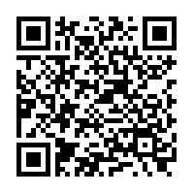  How good are you at this?
Weather  sunny partly cloudy cloudy raining snowing stormy foggy beautiful/perfect cold hot windy clear hailing lightning tornado thunder hurricane/wind  What’s the weather like today?  It’s sunny.  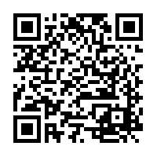  How good are you at this? | Prepositions  behind the box in front of the box in the box by the box over the box between under the box on the box  Where is the book? Where is the rubber? Is the ruler in your bag?  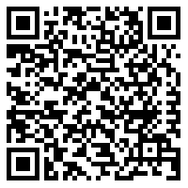  How good are you at this?
Feelings  Happy sad angry hot cold sick thirsty hungry exhausted tired love hate like don’t like  I am….I feel…I love…I like…I don’t like…I hate…  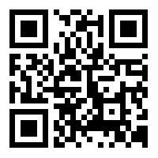  How good are you at this? | Geography  United Kingdom (London) Ireland (Dublin) France (Paris) Spain (Madrid) etc.  What’s the capital of ___________?  Paris is the capital of France.  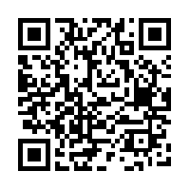  How good are you at this?
Maths  (+) plus, add  (-) take away minus subtract  (÷) divided by shared between  (×) multiplied by times  (=) equals  (%) percent What’s 5 times 2? etc.  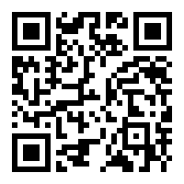  How good are you at this? | Verbs  run read play sleep write talk listen drink eat go watch TV speak sing ride a bike laugh swim play football cook use a computer speak English buy What’s he doing? She’s sleeping Can you (swim)? Yes, I can swim. No, I can’t swim.  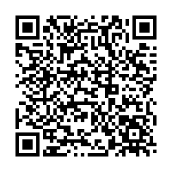  How good are you at this?
Parts of the body  stomach leg foot toe back knee shoulder elbow finger arm neck hand mouth teeth eye ear face nose hair head  I have a sore…  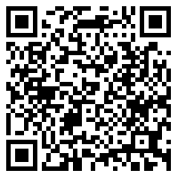  How good are you at this? | Clothes  t-shirt hat shorts skirt socks shoes tie shirt dress pants pyjamas swimsuit gloves coat sweatshirt underwear watch glasses uniform suit  What are you wearing today? I am wearing…  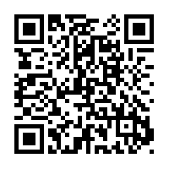  How good are you at this?
Vegetables  onions green peppers tomatoes mushrooms lettuce broccoli potatoes carrots pumpkin beans peas radishes cabbage corn eggplant cucumber  Do you like…? Yes, I do./No, I don’t.  I like … but I don’t like…  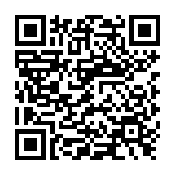  How good are you at this? | Question words  Who? What? Where? When? Why? How? Which? What time?  (How much? How Many?)  Why are you tired? What colour is it? Who is your teacher? Where is the book? What time do you wake up? When is your birthday?  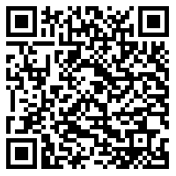  How good are you at this?

