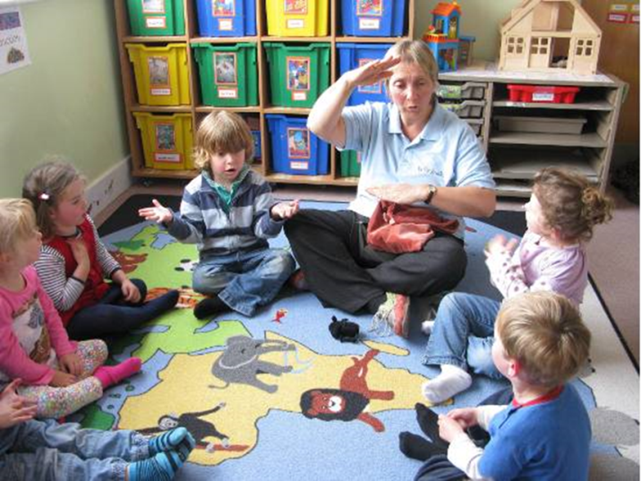

play games with repetitive language

* Teddy Talk / Big Bear Banter
* Song and rhymes – 10 fat sausages, 5 little ducks, 10 green bottles
* I went shopping today and I bought…..
* Pairs / memory game
* Books – Brown bear, brown bear; Dear Zoo etc